AAMA
Brand Audit
Evidence-Based Brand Review & Action Framework

Bracketed text contains instructions or placeholder content. Replace or remove all bracketed text before sharing the completed document.

Field | Entry
Organization / Client | [Enter Client or Organization]
Brand / Business Unit | [Enter Brand or Business Unit]
Audit Owner | [Enter Owner]
Audit Period | [Enter Date or Period]
Primary Decision | [What decision should this audit help make?]

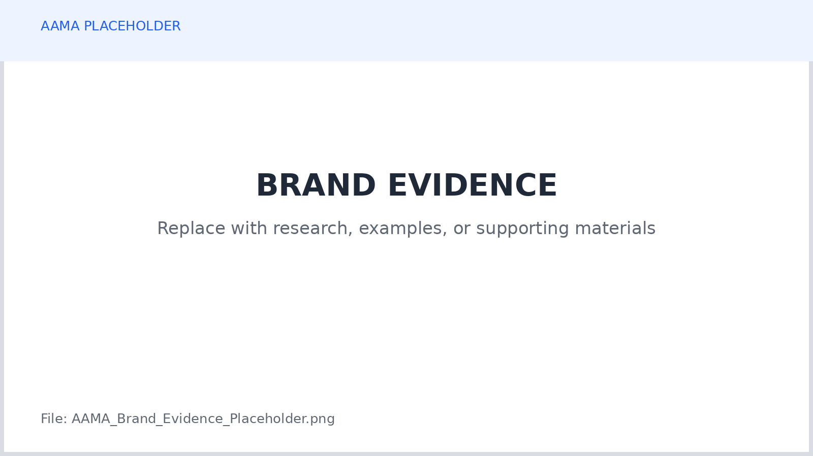

How to Use This Brand Audit
A brand audit is a structured review of how a brand is positioned, expressed, experienced, and managed. It should combine evidence from the market, customers, communications, channels, and internal practice rather than relying on aesthetic preference alone.
Use this worksheet to record evidence, assign ratings, identify gaps, and convert those findings into prioritized actions. A score is useful only when it is supported by evidence and interpreted in the context of the organization's strategy, audience, resources, and market.

Suggested Rating Scale
Score | Meaning
1 | Material weakness or major inconsistency. Immediate attention may be required.
2 | Below standard. Important gaps or inconsistencies are limiting effectiveness.
3 | Adequate. The area generally functions but has meaningful opportunities to improve.
4 | Strong. The area is clear, consistent, and supports strategy with minor opportunities to improve.
5 | Excellent. The area is distinctive, well-supported, consistently applied, and strategically effective.
N/A | Not applicable or insufficient evidence to rate responsibly.

Audit Evidence Sources
Source / Evidence | Date | What It Shows | Confidence | Owner
[Customer research] | [Date] | [Finding] | [High / Medium / Low] | [Owner]
[Brand materials] | [Date] | [Finding] | [High / Medium / Low] | [Owner]
[Analytics / CRM] | [Date] | [Finding] | [High / Medium / Low] | [Owner]
[Competitive research] | [Date] | [Finding] | [High / Medium / Low] | [Owner]

Do not assign a confident score where the supporting evidence is weak. Label uncertainty and create a research action instead.

1. Brand Foundation & Strategic Alignment
Review whether the brand has a clear strategic foundation and whether that foundation is understood consistently across the organization. The purpose is not to reward polished language. The purpose is to determine whether the brand has a useful strategic center that can guide decisions.
Audit Area | Evidence / Observation | Score 1-5 | Implication / Action
Purpose or reason for existence | [What evidence shows the purpose is clear and credible?] | [ ] | [Action]
Brand promise | [Is the promise clear, meaningful, and supportable?] | [ ] | [Action]
Positioning | [Is the target, frame of reference, benefit, and differentiation clear?] | [ ] | [Action]
Business strategy alignment | [Does the brand support current business priorities?] | [ ] | [Action]
Audience relevance | [Does the brand address needs that matter to priority audiences?] | [ ] | [Action]
Internal understanding | [Do teams describe the brand consistently?] | [ ] | [Action]

Foundation Questions
Question | Response
What should the brand be known for? | [Response]
What should customers believe or expect because of the brand? | [Response]
Which current business priorities should the brand help advance? | [Response]
What part of the current brand foundation is no longer accurate? | [Response]

2. Audience & Market Understanding
Evaluate whether the brand reflects current evidence about the audiences and market it serves. A strong brand should be informed by customer behavior and market conditions rather than by internal assumptions about what people supposedly value.
Audit Area | Evidence / Observation | Score 1-5 | Implication / Action
Priority audience definition | [Are the most important audiences clearly identified?] | [ ] | [Action]
Audience needs & motivations | [What evidence supports the stated needs?] | [ ] | [Action]
Decision criteria | [Do we understand how customers compare alternatives?] | [ ] | [Action]
Barriers & objections | [Are important sources of friction understood?] | [ ] | [Action]
Market context | [Does the brand reflect current category and market conditions?] | [ ] | [Action]
Competitive awareness | [Are direct competitors, substitutes, and status quo understood?] | [ ] | [Action]

Research Gaps
Unknown / Uncertain Area | Why It Matters | Recommended Research | Priority
[Research gap] | [Why it affects brand decisions] | [Research action] | [High / Medium / Low]
[Research gap] | [Why it affects brand decisions] | [Research action] | [High / Medium / Low]

3. Positioning & Differentiation
Review whether the brand occupies a clear and meaningful position relative to customer alternatives. Differentiation is useful only when the audience understands it, values it, and the organization can support it.
Audit Area | Evidence / Observation | Score 1-5 | Implication / Action
Frame of reference | [Is it clear what market or problem the brand belongs to?] | [ ] | [Action]
Primary benefit | [Is the central value clear and relevant?] | [ ] | [Action]
Meaningful differentiation | [What makes the brand distinct in a way customers value?] | [ ] | [Action]
Reasons to believe | [Is there credible proof behind the promise?] | [ ] | [Action]
Competitive distinctiveness | [Does the brand avoid generic category language?] | [ ] | [Action]
Defensibility | [How difficult is the position or advantage to reproduce?] | [ ] | [Action]

Current Positioning Statement
Element | Current / Proposed Definition
Priority audience | [Audience]
Frame of reference | [Category / problem context]
Primary benefit | [Benefit]
Meaningful difference | [Difference]
Reasons to believe | [Proof]

Positioning Risks
Risk | Evidence | Consequence | Action
[Generic claim / crowded position / weak proof] | [Evidence] | [Consequence] | [Action]
[Risk] | [Evidence] | [Consequence] | [Action]

4. Messaging & Brand Voice
Evaluate whether the brand communicates a coherent message and recognizable voice across major contexts. Consistency does not mean identical language everywhere. It means the communication remains strategically connected while adapting appropriately to the audience and situation.
Audit Area | Evidence / Observation | Score 1-5 | Implication / Action
Core message | [Is the central idea clear and consistently communicated?] | [ ] | [Action]
Message hierarchy | [Are supporting messages organized around the core idea?] | [ ] | [Action]
Proof & claims | [Are important claims supportable and clearly evidenced?] | [ ] | [Action]
Brand voice | [Is the writing character recognizable and useful?] | [ ] | [Action]
Tone adaptation | [Does tone change appropriately by context without losing the voice?] | [ ] | [Action]
Clarity & accessibility | [Is communication understandable and accessible to the intended audience?] | [ ] | [Action]

Message / Language Pattern | Keep | Change | Evidence / Reason
[Current message or phrase] | [ ] | [ ] | [Reason]
[Current message or phrase] | [ ] | [ ] | [Reason]
[Current message or phrase] | [ ] | [ ] | [Reason]

5. Visual Identity & Recognition
Review how effectively the visual identity supports recognition, positioning, credibility, usability, and consistency. The goal is not to judge design according to personal taste. Evaluate whether the system helps the brand communicate and function across the environments where audiences encounter it.
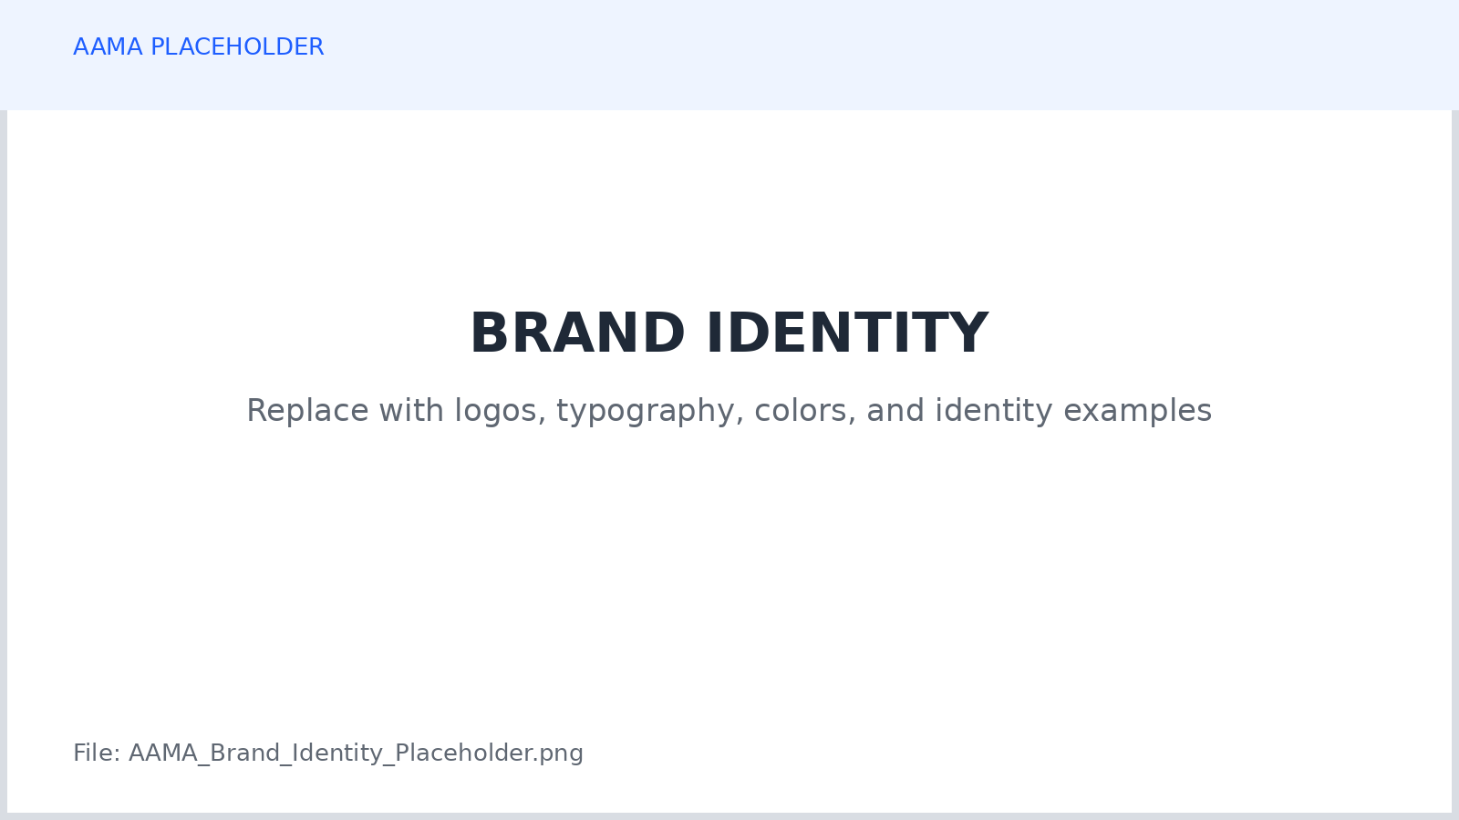

Audit Area | Evidence / Observation | Score 1-5 | Implication / Action
Logo system | [Is the identity recognizable and usable across required formats?] | [ ] | [Action]
Color system | [Is the palette consistent, accessible, and practical?] | [ ] | [Action]
Typography | [Is typography consistent, readable, and appropriate?] | [ ] | [Action]
Imagery / art direction | [Does imagery reinforce the intended brand character?] | [ ] | [Action]
Layout / composition | [Are design patterns coherent across communications?] | [ ] | [Action]
Accessibility | [Do contrast, readability, and visual choices support access?] | [ ] | [Action]
Scalability | [Can the identity system work across small and large applications?] | [ ] | [Action]

6. Customer Experience & Brand Touchpoints
A brand is experienced through more than advertising. Sales, service, onboarding, fulfillment, products, events, digital interfaces, billing, and other touchpoints can strengthen or contradict the promise communicated by marketing.
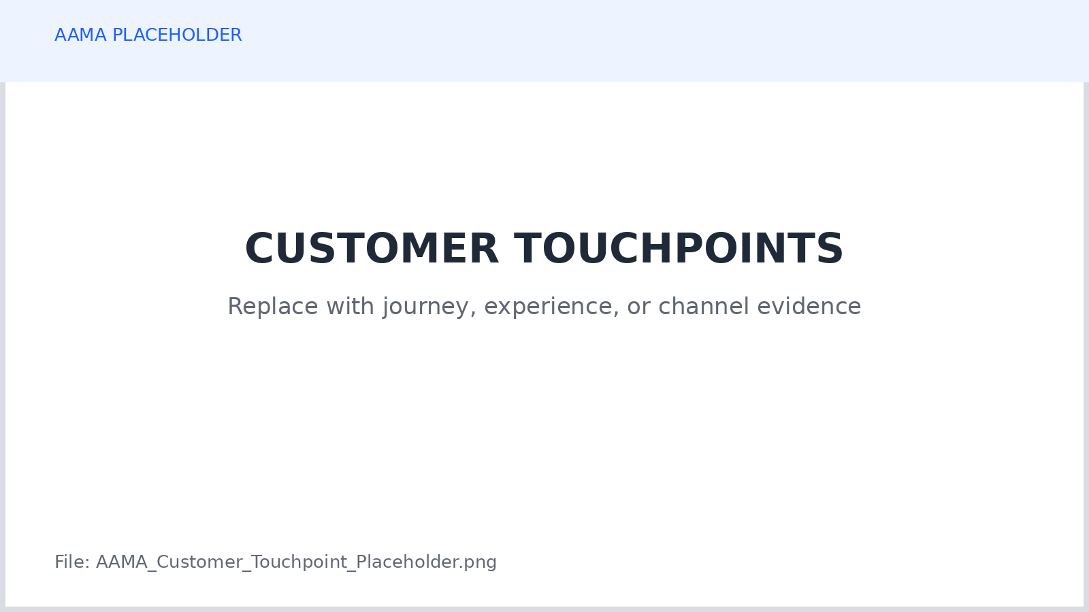

Touchpoint | Brand Promise Delivered? | Evidence / Friction | Score 1-5 | Action
Website / digital experience | [Yes / Partly / No] | [Observation] | [ ] | [Action]
Sales / inquiry experience | [Yes / Partly / No] | [Observation] | [ ] | [Action]
Purchase / conversion | [Yes / Partly / No] | [Observation] | [ ] | [Action]
Onboarding / first use | [Yes / Partly / No] | [Observation] | [ ] | [Action]
Customer service | [Yes / Partly / No] | [Observation] | [ ] | [Action]
Retention / renewal | [Yes / Partly / No] | [Observation] | [ ] | [Action]

Promise-to-Experience Gaps
Promised Experience | Actual Experience | Gap | Business / Brand Risk
[Promise] | [Observed reality] | [Gap] | [Risk]
[Promise] | [Observed reality] | [Gap] | [Risk]

7. Channel & Digital Presence
Review whether the brand appears coherently and effectively across the channels where priority audiences discover, evaluate, purchase, use, or discuss it. Channel consistency should support recognition while still respecting the different roles and conventions of each environment.
Channel / Environment | Role | Consistency | Effectiveness Evidence | Score 1-5 | Action
Website | [Role] | [Strong / Mixed / Weak] | [Evidence] | [ ] | [Action]
Search / discovery | [Role] | [Strong / Mixed / Weak] | [Evidence] | [ ] | [Action]
Email / CRM | [Role] | [Strong / Mixed / Weak] | [Evidence] | [ ] | [Action]
Social / community | [Role] | [Strong / Mixed / Weak] | [Evidence] | [ ] | [Action]
Paid advertising | [Role] | [Strong / Mixed / Weak] | [Evidence] | [ ] | [Action]
Sales / partner materials | [Role] | [Strong / Mixed / Weak] | [Evidence] | [ ] | [Action]

Channel Gaps & Duplication
Observation | Evidence | Implication | Action
[Important audience is difficult to reach] | [Evidence] | [Implication] | [Action]
[Channels repeat activity without distinct roles] | [Evidence] | [Implication] | [Action]

8. Internal Alignment, Consistency & Governance
Evaluate whether the organization has the systems required to maintain the brand over time. A strong strategy and identity can deteriorate when ownership is unclear, guidance is inaccessible, approvals are inconsistent, or teams operate from different versions of the brand.
Audit Area | Evidence / Observation | Score 1-5 | Implication / Action
Brand ownership | [Is responsibility clearly assigned?] | [ ] | [Action]
Guidelines & documentation | [Are current standards documented and accessible?] | [ ] | [Action]
Asset management | [Can teams locate approved current assets?] | [ ] | [Action]
Training & onboarding | [Do relevant teams understand how to use the brand?] | [ ] | [Action]
Review & approval | [Is feedback based on agreed standards?] | [ ] | [Action]
Agency / partner consistency | [Do external contributors receive useful guidance?] | [ ] | [Action]
Measurement & review cadence | [Is brand performance reviewed regularly?] | [ ] | [Action]

Governance Gaps
Gap | Risk | Owner | Recommended Fix | Priority
[Gap] | [Risk] | [Owner] | [Action] | [High / Medium / Low]
[Gap] | [Risk] | [Owner] | [Action] | [High / Medium / Low]

9. Brand Audit Scorecard
Use the scorecard to summarize the audit. Ratings should reflect the evidence recorded in the earlier sections. A low score does not automatically mean the brand needs a complete redesign, and a high score does not mean improvement is unnecessary.
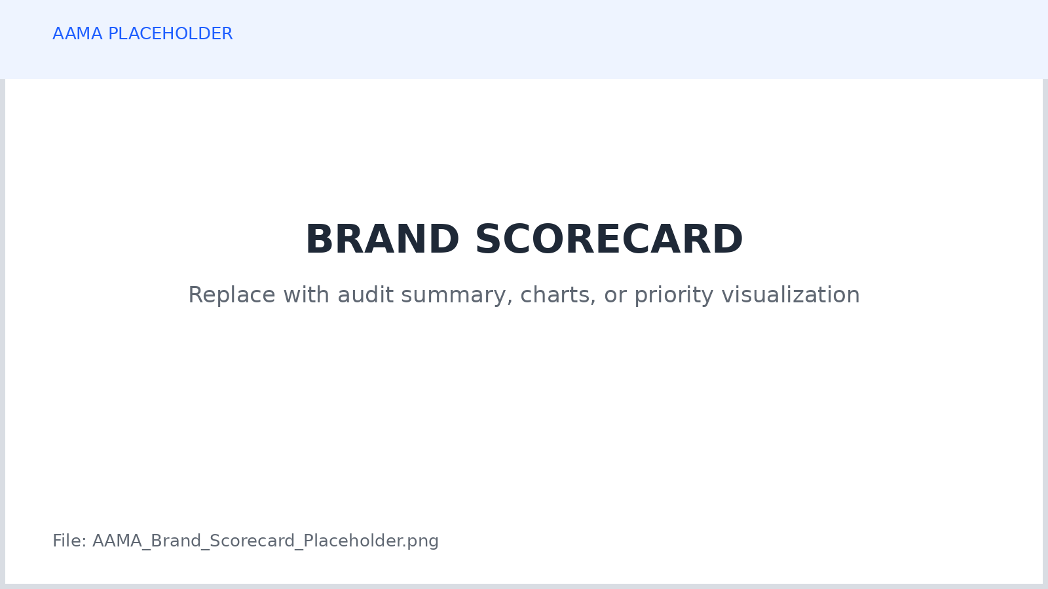

Audit Dimension | Score 1-5 | Evidence Confidence | Priority | Summary Finding
Brand Foundation & Strategic Alignment | [ ] | [High / Medium / Low] | [High / Medium / Low] | [Finding]
Audience & Market Understanding | [ ] | [High / Medium / Low] | [High / Medium / Low] | [Finding]
Positioning & Differentiation | [ ] | [High / Medium / Low] | [High / Medium / Low] | [Finding]
Messaging & Brand Voice | [ ] | [High / Medium / Low] | [High / Medium / Low] | [Finding]
Visual Identity & Recognition | [ ] | [High / Medium / Low] | [High / Medium / Low] | [Finding]
Customer Experience & Touchpoints | [ ] | [High / Medium / Low] | [High / Medium / Low] | [Finding]
Channel & Digital Presence | [ ] | [High / Medium / Low] | [High / Medium / Low] | [Finding]
Internal Alignment & Governance | [ ] | [High / Medium / Low] | [High / Medium / Low] | [Finding]

Overall Brand Condition
Question | Response
What is the brand doing particularly well? | [Response]
What is the most important weakness? | [Response]
What is the largest inconsistency? | [Response]
What is the most important opportunity? | [Response]
What should not be changed? | [Response]

10. Prioritized Brand Action Plan
Translate the audit into a manageable set of decisions. Prioritize actions according to strategic importance, evidence, customer impact, business impact, urgency, and the resources required to implement the change.
Priority Action | Finding / Evidence | Owner | Timing | Effort | Expected Impact | Status
[Action 1] | [Evidence] | [Owner] | [Timing] | [Low / Med / High] | [Impact] | [Open]
[Action 2] | [Evidence] | [Owner] | [Timing] | [Low / Med / High] | [Impact] | [Open]
[Action 3] | [Evidence] | [Owner] | [Timing] | [Low / Med / High] | [Impact] | [Open]
[Action 4] | [Evidence] | [Owner] | [Timing] | [Low / Med / High] | [Impact] | [Open]
[Action 5] | [Evidence] | [Owner] | [Timing] | [Low / Med / High] | [Impact] | [Open]

30 / 90 / 180-Day Priorities
Time Horizon | Primary Priorities | Decision / Deliverable | Owner
Next 30 Days | [Priorities] | [Deliverable] | [Owner]
Next 90 Days | [Priorities] | [Deliverable] | [Owner]
Next 180 Days | [Priorities] | [Deliverable] | [Owner]

Research & Validation Actions
Question to Resolve | Method | Owner | Timing | Decision It Will Inform
[Question] | [Research / test] | [Owner] | [Timing] | [Decision]
[Question] | [Research / test] | [Owner] | [Timing] | [Decision]

11. Final Brand Audit Review
Complete this review before presenting the audit. The goal is to confirm that the conclusions are supported, important uncertainty is visible, and the final recommendations reflect the organization's actual strategy and customer evidence rather than personal preference.
[ ] The purpose and scope of the audit are clearly defined.
[ ] Major conclusions can be traced to identifiable evidence.
[ ] Facts, interpretations, assumptions, and preferences are not presented as the same thing.
[ ] Audience and market findings are reasonably current.
[ ] Positioning and differentiation are evaluated from the customer perspective, not only internally.
[ ] Messaging and visual identity are evaluated for strategic usefulness as well as consistency.
[ ] Customer experience is included in the audit rather than limiting the review to advertising and design.
[ ] Accessibility and inclusion have been considered where relevant.
[ ] Important governance and ownership gaps are documented.
[ ] The highest-priority recommendations are specific enough to act on.
[ ] Areas with weak evidence have research or validation actions rather than false certainty.
[ ] The audit identifies what should be preserved as well as what should change.

Final Audit Decision
Decision Area | Response
Overall brand condition | [Strong / Stable / Needs Focused Improvement / Needs Significant Change / Insufficient Evidence]
Immediate priority | [Priority]
Next major decision | [Decision]
Audit owner | [Owner]
Next review date | [Date]

Template originally provided by the American Advertising and Marketing Association.

