AMERICAN ADVERTISING AND MARKETING ASSOCIATION

Case Study Analysis Worksheet
A structured worksheet for examining marketing and advertising cases, evidence quality, strategic logic, execution, results, causality, limitations, and transferable lessons.
Field | Case Information
Case / Campaign | [Enter Case Study or Campaign]
Organization / Brand | [Enter Organization or Brand]
Industry / Category | [Enter Industry or Category]
Period | [Enter Campaign or Case Period]
Primary Source | [Enter Publication, Organization, Journal, Archive, or URL]
Analyst / Student | [Enter Name]
Date | [Enter Date]

Bracketed text contains instructions or placeholder content. Replace or remove all bracketed text before sharing the completed document. The worksheet is designed to analyze a case study critically, not to assume that the narrative presented by a brand, agency, platform, publisher, award program, or researcher proves what caused the reported result.

Analysis Principles
Principle | Application
Separate fact from interpretation | Record what is directly supported before explaining what it may mean.
Separate attribution from causality | A credited conversion or reported correlation does not automatically prove the campaign caused the outcome.
Evaluate evidence quality | Consider source incentives, methodology, missing baselines, sample size, comparison groups, and unavailable data.
Analyze the whole system | Review problem, audience, strategy, execution, media, experience, timing, operations, and measurement.
Extract conditional lessons | Identify what may transfer to another situation and the conditions that would need to be similar.

1. Source, Case & Evidence Quality
Begin by evaluating what kind of case study you are reading and who produced it. Marketing cases often serve educational, promotional, award, sales, public-relations, or academic purposes, and those incentives affect what information may be included or omitted.
Source Question | Response
Primary source type | [Brand / agency / platform / award entry / academic paper / trade publication / journalism / archive / other]
Who created the case? | [Identify author, organization, agency, publisher, or researcher.]
Who supplied the data? | [Identify source of campaign, sales, research, platform, or customer data.]
What incentive may shape the narrative? | [Promotion, award submission, sales proof, scholarship, journalism, historical documentation, etc.]
Is methodology disclosed? | [Yes / partial / no. Summarize what is available.]
Are definitions clear? | [Identify unclear terms such as engagement, conversion, lift, reach, ROI, awareness, or acquisition.]
What important evidence is missing? | [Baseline, control, budget, denominator, sample, time period, profit, customer quality, etc.]

Evidence Inventory
Evidence / Claim | Source | Direct Evidence or Interpretation? | Confidence
[Finding or claim] | [Source] | [Direct / interpreted] | [High / medium / low]
[Finding or claim] | [Source] | [Direct / interpreted] | [High / medium / low]
[Finding or claim] | [Source] | [Direct / interpreted] | [High / medium / low]
[Finding or claim] | [Source] | [Direct / interpreted] | [High / medium / low]
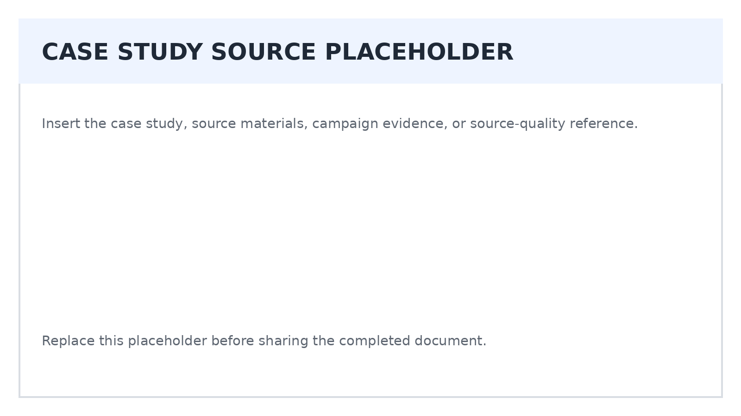

2. Context, Problem & Stakes
Reconstruct the conditions that existed before the campaign or initiative began. A result cannot be interpreted well without understanding the problem, market conditions, organizational situation, and consequences of success or failure.
Context Area | Analysis
Business / organizational situation | [What was happening before the initiative?]
Marketing problem | [What specific marketing or communication problem needed to change?]
Market / category conditions | [Competition, category growth, disruption, seasonality, regulation, technology, culture, distribution, etc.]
Customer behavior | [What audience behavior or perception was relevant?]
Operational conditions | [Inventory, staffing, distribution, service capacity, product changes, pricing, availability, etc.]
Timing / external events | [What happened in the market or culture during the case period?]
Stakes | [What happened if the organization succeeded, failed, or did nothing?]

Problem Statement
Rewrite the case problem in one precise statement. Avoid describing the solution as the problem.
[Enter response]

Case Baseline
Baseline Measure | Before / Control Value | Source | Confidence
[Sales / awareness / conversion / share / traffic / etc.] | [Value] | [Source] | [Confidence]
[Measure] | [Value] | [Source] | [Confidence]
[Measure] | [Value] | [Source] | [Confidence]

3. Objective, Audience & Intended Change
Identify what the initiative was expected to accomplish and what needed to change in the audience. Distinguish organizational outcomes from marketing outcomes, communication effects, and customer behavior.
Level | Case Objective / Intended Change | Evidence
Business / organizational outcome | [Revenue, share, retention, demand, participation, adoption, etc.] | [Source]
Marketing outcome | [Qualified demand, consideration, acquisition, usage, loyalty, etc.] | [Source]
Communication outcome | [Awareness, understanding, association, recall, preference, etc.] | [Source]
Customer behavior | [Search, visit, trial, purchase, register, return, recommend, etc.] | [Source]

Audience Analysis
Audience Question | Analysis
Priority audience | [Who was the initiative trying to influence?]
Need / motivation | [What did this audience want or value?]
Barrier / objection | [What prevented the desired behavior?]
Current alternative | [What did the audience do instead?]
Decision criteria | [What factors affected choice?]
Evidence behind audience definition | [Research, analytics, sales data, interviews, assumptions, etc.]

Audience Evidence Quality
Which audience conclusions are strongly supported, which appear assumed, and what research would improve confidence?
[Enter response]

4. Strategic Logic & Hypothesis
Identify the strategy that connects the problem with the intended outcome. Strategy should explain why the chosen approach was expected to change behavior, not simply list the channels or creative executions used.
Strategic Element | Analysis
Insight | [What customer, market, cultural, or behavioral insight appears to drive the strategy?]
Strategic choice | [What did the organization choose to do, and what did it choose not to do?]
Value proposition / promise | [What value was offered or communicated?]
Positioning | [How was the organization, product, or idea positioned relative to alternatives?]
Behavioral mechanism | [Why was the strategy expected to influence attention, memory, motivation, trust, choice, or action?]
Reason to believe | [What proof or credibility supported the promise?]

Reconstruct the Strategic Hypothesis
If... | Then... | Because... | Evidence Needed
[Strategic action] | [Expected audience response] | [Mechanism or rationale] | [What would support the hypothesis?]
[Strategic action] | [Expected response] | [Rationale] | [Evidence]

Strategic Alternatives
Alternative Strategy | Why It May Have Been Considered | Why the Case Chose Differently / Unknown
[Alternative] | [Rationale] | [Evidence or unknown]
[Alternative] | [Rationale] | [Evidence or unknown]
[Alternative] | [Rationale] | [Evidence or unknown]

5. Execution, Creative & Channel System
Analyze how the strategy was translated into actual customer-facing work. Execution should be evaluated as a system across message, creative, media, channel roles, timing, offer, landing experience, sales, and service where relevant.
Execution Area | What Happened | Role in Strategy | Evidence / Assessment
Creative idea / message | [Describe] | [Role] | [Assessment]
Offer / call to action | [Describe] | [Role] | [Assessment]
Paid media | [Describe] | [Role] | [Assessment]
Owned media / CRM | [Describe] | [Role] | [Assessment]
Earned / PR / partnerships | [Describe] | [Role] | [Assessment]
Social / creator activity | [Describe] | [Role] | [Assessment]
Landing / conversion experience | [Describe] | [Role] | [Assessment]
Sales / service / operations | [Describe] | [Role] | [Assessment]
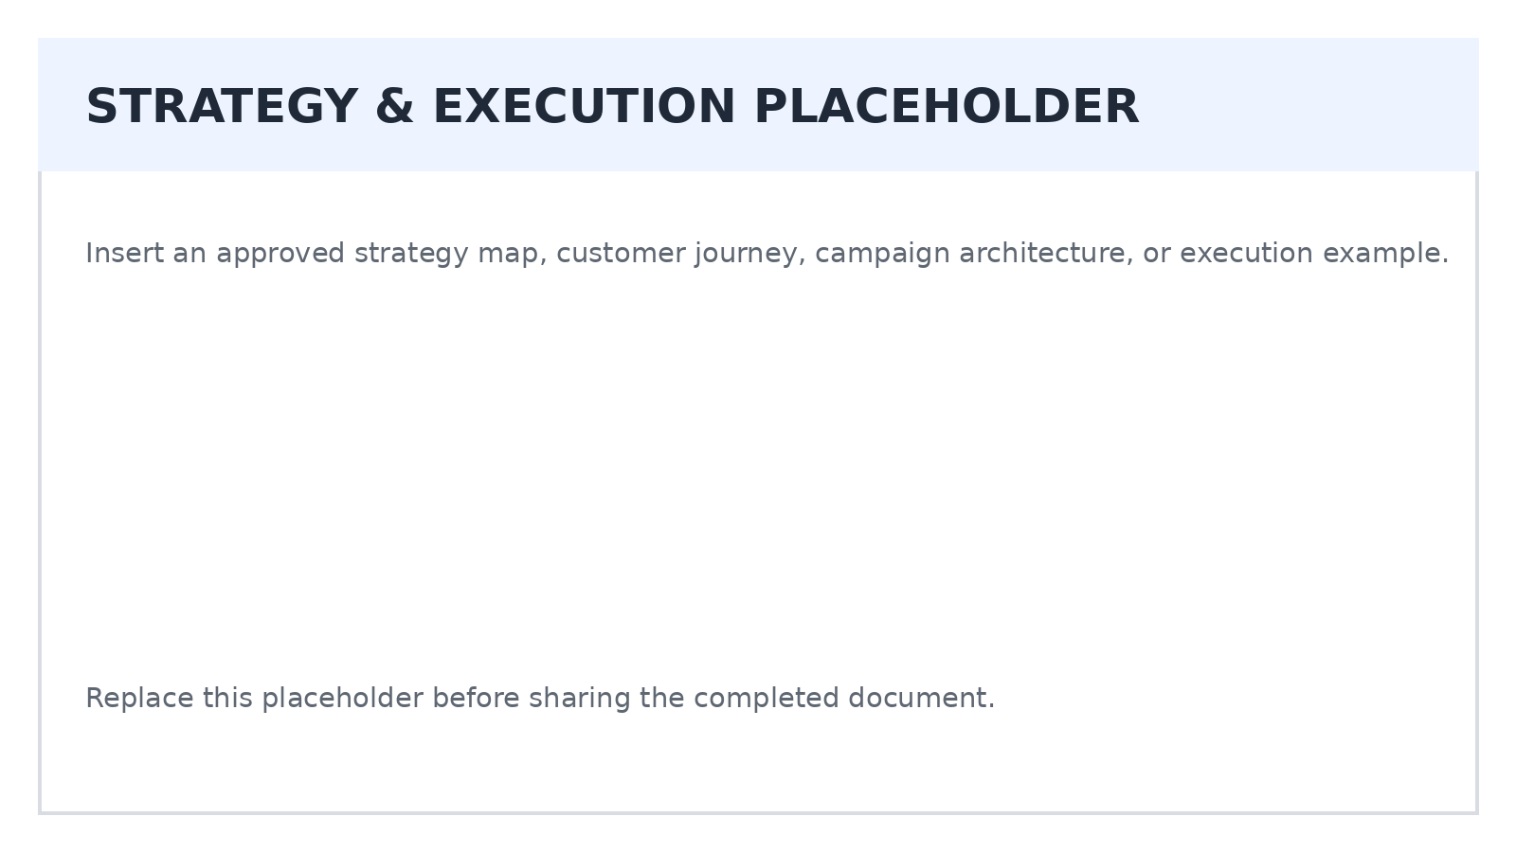

Execution Consistency
Where did execution reinforce the strategy, and where did it dilute, contradict, or fail to support it?
[Enter response]

6. Media, Timing, Budget & Exposure
Evaluate whether the case provides enough information to understand the scale of the activity. Results are difficult to interpret when media investment, campaign duration, reach, frequency, distribution, or other exposure conditions are omitted.
Media / Exposure Question | Case Evidence
Campaign period | [Dates / duration]
Geography | [Market / markets]
Budget / investment | [Amount, range, share of budget, or not disclosed]
Primary channels | [Channels and roles]
Reach | [Unique audience or not disclosed]
Frequency | [Average exposure or not disclosed]
Impressions / delivery | [Reported delivery or not disclosed]
Share of voice / competitive pressure | [Evidence or unknown]
Distribution / availability | [Where product, service, or offer could actually be obtained]

Scale Interpretation
Question | Analysis
Could the reported result be partly explained by spending more? | [Analysis]
Could wider distribution or availability explain part of the result? | [Analysis]
Did the case disclose enough information to judge efficiency? | [Analysis]
Was timing unusually favorable or unfavorable? | [Analysis]

Missing Media Evidence
List exposure, budget, timing, or distribution information that would materially improve the analysis.
[Enter response]

7. Measurement, Results & Claims
Record results precisely and identify how each result was measured. Keep delivery metrics, response metrics, customer outcomes, financial outcomes, and research findings separate so they are not treated as equivalent evidence.
Reported Result | Value / Change | Metric Type | Source / Method | Confidence
[Result 1] | [Value] | [Delivery / response / customer / financial / research] | [Source] | [High / medium / low]
[Result 2] | [Value] | [Type] | [Source] | [Confidence]
[Result 3] | [Value] | [Type] | [Source] | [Confidence]
[Result 4] | [Value] | [Type] | [Source] | [Confidence]
[Result 5] | [Value] | [Type] | [Source] | [Confidence]

Measurement Method
Measurement Question | Analysis
What was the denominator? | [Identify denominator behind rates, lift, ROI, conversion, etc.]
What was the comparison? | [Prior period, target, control, market, benchmark, forecast, none]
Was a control or holdout used? | [Yes / no / unclear. Describe.]
Was the result attributed or experimentally estimated? | [Describe.]
Were costs fully included? | [Media only, marketing cost, promotion, agency, production, incentives, etc.]
Were results statistically or practically meaningful? | [Evidence / unknown]
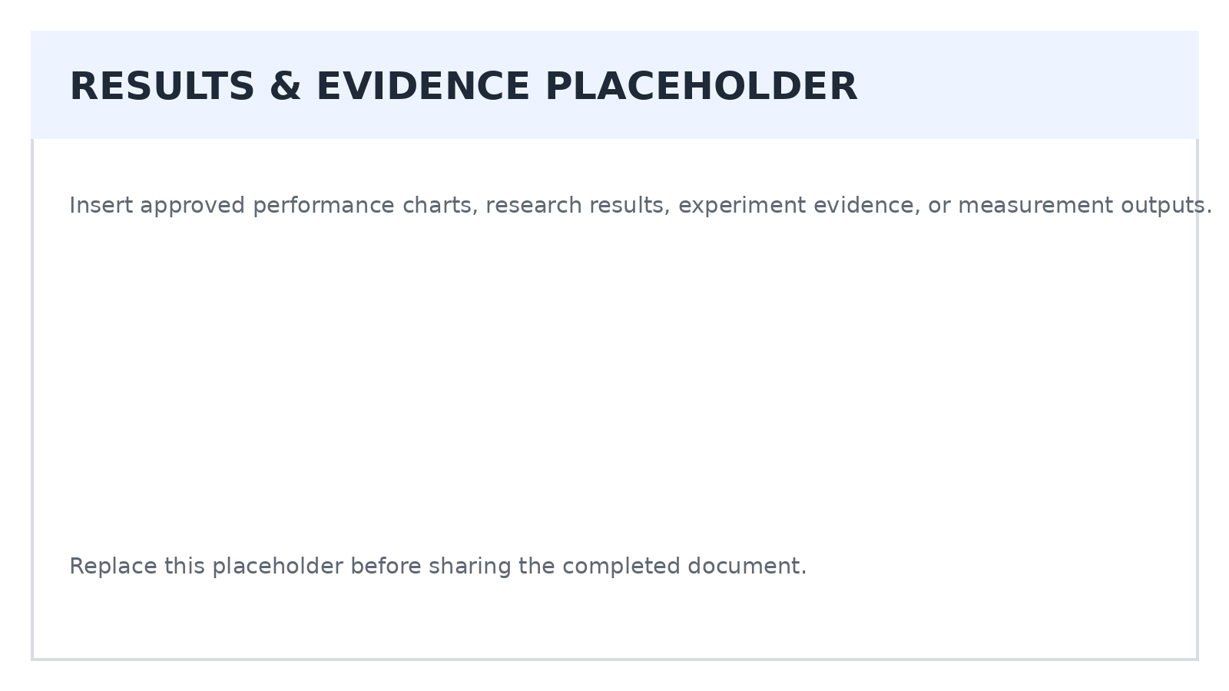

8. Causality & Alternative Explanations
Ask what else could plausibly have produced or contributed to the reported result. A credible case analysis considers competing explanations before crediting the campaign or tactic.
Potential Explanation | Could It Affect the Result? | Evidence For / Against | Confidence
Campaign / marketing activity | [Yes / no / unclear] | [Evidence] | [Confidence]
Price or promotion change | [Yes / no / unclear] | [Evidence] | [Confidence]
Distribution / availability change | [Yes / no / unclear] | [Evidence] | [Confidence]
Product or service improvement | [Yes / no / unclear] | [Evidence] | [Confidence]
Seasonality / timing | [Yes / no / unclear] | [Evidence] | [Confidence]
Competitive activity | [Yes / no / unclear] | [Evidence] | [Confidence]
Economic / cultural / news event | [Yes / no / unclear] | [Evidence] | [Confidence]
Measurement / attribution change | [Yes / no / unclear] | [Evidence] | [Confidence]
Selection / survivorship bias | [Yes / no / unclear] | [Evidence] | [Confidence]

Causal Conclusion
Conclusion | Response
What can reasonably be said? | [State the strongest conclusion supported by the evidence.]
What cannot be claimed? | [State conclusions the evidence does not justify.]
What additional evidence would strengthen the causal claim? | [Control, experiment, matched market, incremental lift, better baseline, etc.]

9. Limitations, Bias & Missing Information
Identify how the case study format itself may shape the story. Published cases often emphasize successful choices and outcomes while providing limited information about failed tests, competing explanations, internal disagreement, cost, or what happened after the featured period ended.
Limitation / Bias | How It May Affect Interpretation | Materiality
Self-reported case | [Analysis] | [High / medium / low]
Award / promotional selection bias | [Analysis] | [Materiality]
Missing unsuccessful tests | [Analysis] | [Materiality]
Missing budget or cost detail | [Analysis] | [Materiality]
Missing baseline or control | [Analysis] | [Materiality]
Short measurement period | [Analysis] | [Materiality]
Unclear attribution | [Analysis] | [Materiality]
No profit / customer quality / retention evidence | [Analysis] | [Materiality]
Unreported operational changes | [Analysis] | [Materiality]

Missing Questions
Question the Case Does Not Answer | Why It Matters | How You Would Investigate It
[Question] | [Reason] | [Method / source]
[Question] | [Reason] | [Method / source]
[Question] | [Reason] | [Method / source]
[Question] | [Reason] | [Method / source]

10. Strategic Assessment & Transferability
Evaluate the quality of the strategic reasoning separately from whether the case reports a successful outcome. Then identify which lessons might transfer to another organization and the conditions that would need to be similar.
Assessment Area | Rating | Evidence / Rationale
Problem definition | [1-5] | [Rationale]
Audience understanding | [1-5] | [Rationale]
Strategic coherence | [1-5] | [Rationale]
Differentiation / positioning | [1-5] | [Rationale]
Execution quality | [1-5] | [Rationale]
Channel / media logic | [1-5] | [Rationale]
Measurement quality | [1-5] | [Rationale]
Evidence quality | [1-5] | [Rationale]
Causal confidence | [1-5] | [Rationale]
Transferability | [1-5] | [Rationale]

Transferable Lessons
Potential Lesson | Conditions Required | What Should Not Be Generalized
[Lesson] | [Audience, market, budget, channel, timing, product, etc.] | [Limit]
[Lesson] | [Conditions] | [Limit]
[Lesson] | [Conditions] | [Limit]
[Lesson] | [Conditions] | [Limit]
A case study can be useful without being universally replicable. The strongest lesson often describes a principle, decision process, or testable hypothesis rather than a command to copy the featured tactic.

11. Final Analysis, Lessons & Next Questions
Synthesize the case into a concise conclusion that preserves uncertainty. The final analysis should make clear what happened, what likely mattered, what remains unproven, and how the case can inform future marketing work.
Final Analysis | Response
Case in one sentence | [Summarize the case without promotional language.]
Most important strategic decision | [Identify the decision with the greatest apparent importance.]
Strongest evidence | [Identify the most credible evidence in the case.]
Weakest evidence / biggest gap | [Identify the most important limitation.]
Most plausible causal explanation | [State with appropriate qualification.]
Most useful lesson | [State a transferable principle or hypothesis.]
Most important caution | [State what another marketer should not assume from this case.]
Best next research question | [Identify what should be tested or investigated next.]

Actionable Learning
Decision Area | Preserve / Apply | Test Before Applying | Avoid / Reject
Strategy | [Lesson] | [Hypothesis] | [Practice]
Audience / Research | [Lesson] | [Hypothesis] | [Practice]
Creative / Messaging | [Lesson] | [Hypothesis] | [Practice]
Media / Distribution | [Lesson] | [Hypothesis] | [Practice]
Measurement | [Lesson] | [Hypothesis] | [Practice]

Case Study Analysis Checklist
Review Question | Complete
Source incentives and evidence quality were evaluated. | [ ]
Facts were separated from interpretations and promotional claims. | [ ]
The original problem, context, audience, and baseline were identified. | [ ]
The strategic hypothesis was reconstructed rather than inferred from tactics alone. | [ ]
Execution, media, timing, budget, and operational conditions were considered. | [ ]
Reported results were tied to definitions, methods, and comparison points. | [ ]
Attribution was not automatically treated as proof of causality. | [ ]
Alternative explanations and case-study limitations were documented. | [ ]
Transferable lessons include the conditions under which they may apply. | [ ]
The final conclusion clearly states what remains unknown. | [ ]
The purpose of case study analysis is not to discredit successful marketing work. It is to understand what the available evidence can support, what the case can teach, and which conclusions require additional testing before they are applied elsewhere.

