MARKETING PLAN
Template
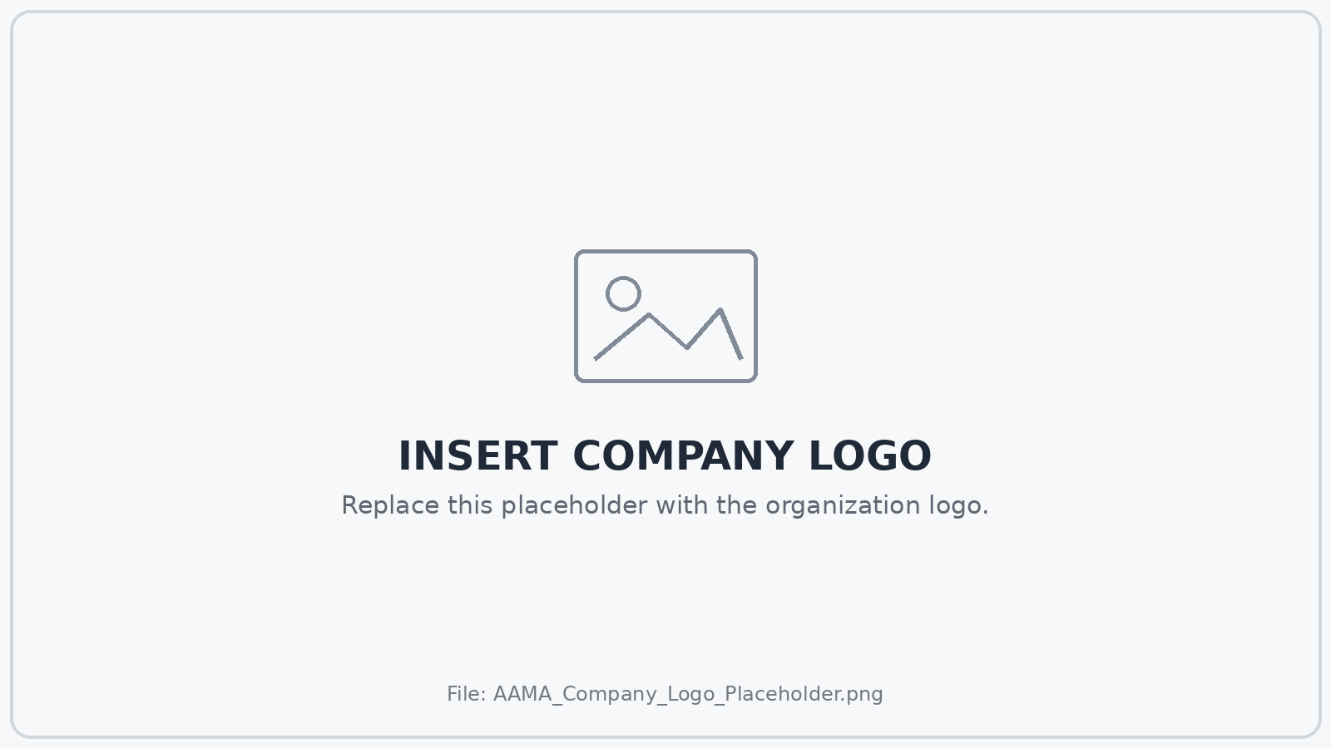
[Replace with organization logo]
Organization | [Enter Organization]
Plan Period | [Enter Date Range]
Prepared By | [Enter Name / Team]
Version | [Enter Version]
Last Updated | [Enter Date]

Bracketed text contains instructions or placeholder content. Replace or remove all bracketed text before sharing the completed document.

How to Use This Template
This template is designed to help professionals, organizations, students, and academic teams build a complete marketing plan without forcing every project into the same level of detail. Keep the sections that support the decision you are making, expand areas that require deeper analysis, and remove sections that are not relevant to the final plan.
Use bracketed text as working instructions. Replace all bracketed material with your own content before presenting or distributing the plan. Image placeholders can be replaced in Word by selecting the image and using Change Picture.

Recommended Planning Sequence
Step | Focus | Primary Output
1 | Situation | Current market, customer, company, and competitive context
2 | Objectives | Business and marketing outcomes the plan must support
3 | Audience | Priority customer or stakeholder groups and relevant insights
4 | Positioning | Value proposition, differentiation, message, and proof
5 | Strategy | Strategic choices, channel roles, and campaign approach
6 | Execution | Content, creative, media, calendar, ownership, and budget
7 | Measurement | KPIs, reporting, testing, optimization, and decisions

Plan Summary
Planning Prompt | Response / Working Notes
Plan purpose | [In 2-4 sentences, explain why this marketing plan exists and what decisions it is intended to guide.]
Planning period | [Enter the dates covered by this plan.]
Primary business priority | [State the business priority marketing is expected to support.]
Primary marketing objective | [State the most important measurable marketing outcome.]
Primary audience | [Identify the highest-priority audience.]
Primary strategic idea | [Summarize the core strategic approach in one concise paragraph.]

1. Executive Summary
The executive summary should allow a senior reader to understand the plan without reading every supporting section. Write it after the rest of the plan is substantially complete, even though it appears first.
Planning Prompt | Response / Working Notes
Business context | [Summarize the business situation, opportunity, or problem that makes this plan necessary.]
Marketing objective | [State the primary objective and the measurement period.]
Audience priority | [Identify the audience whose behavior or perception matters most.]
Strategy | [Summarize the strategic choices, not the full list of tactics.]
Investment | [Summarize the proposed marketing budget or resource commitment.]
Success criteria | [List the primary KPIs or business outcomes that will determine success.]

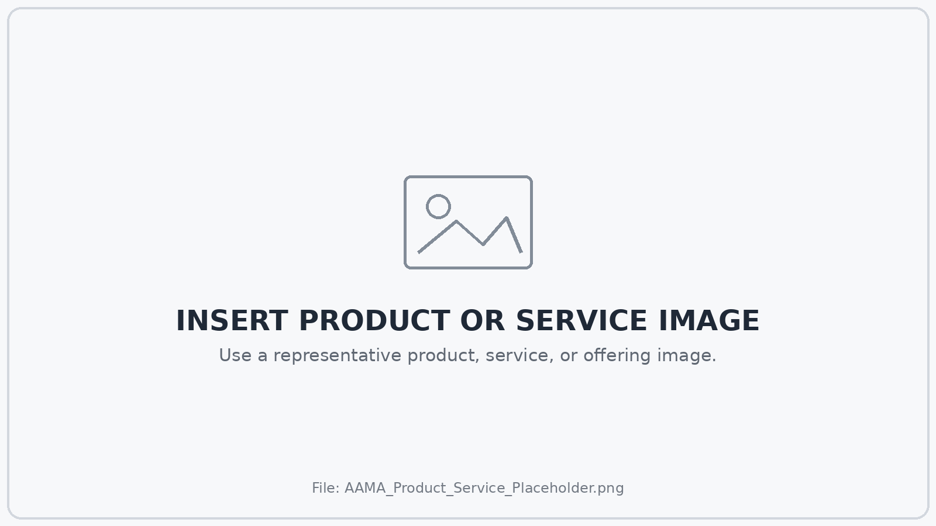
[Optional: replace with a representative product or service image]

2. Situation Analysis
Situation analysis establishes the evidence behind the plan. Separate known facts from assumptions, and identify where additional research is required before major commitments are made.

Market & Category Context
Planning Prompt | Response / Working Notes
Market definition | [Define the market or category being addressed.]
Market size / opportunity | [Summarize available market size, growth, demand, or opportunity estimates. Cite sources in the notes.]
Major trends | [Identify economic, cultural, technological, regulatory, behavioral, or competitive trends affecting the market.]
Customer behavior | [Summarize how customers currently discover, evaluate, purchase, use, or recommend solutions in this category.]
Key constraints | [Identify material budget, regulatory, operational, product, geographic, distribution, or timing constraints.]


[Replace with market, category, geographic, or competitive-context visual]

Company / Offering Context
Planning Prompt | Response / Working Notes
Offering | [Describe the product, service, program, membership, cause, or experience being marketed.]
Current performance | [Summarize relevant sales, demand, traffic, awareness, acquisition, retention, or other baseline performance.]
Strengths | [What advantages does the organization currently possess?]
Weaknesses | [What internal limitations could reduce marketing effectiveness?]
Strategic opportunity | [What opportunity can marketing realistically help the organization capture?]

3. Target Audience & Customer Insight
Define audiences according to the decision the plan must influence. Avoid building personas from decorative demographic detail that does not change strategy, messaging, channel selection, or customer experience.
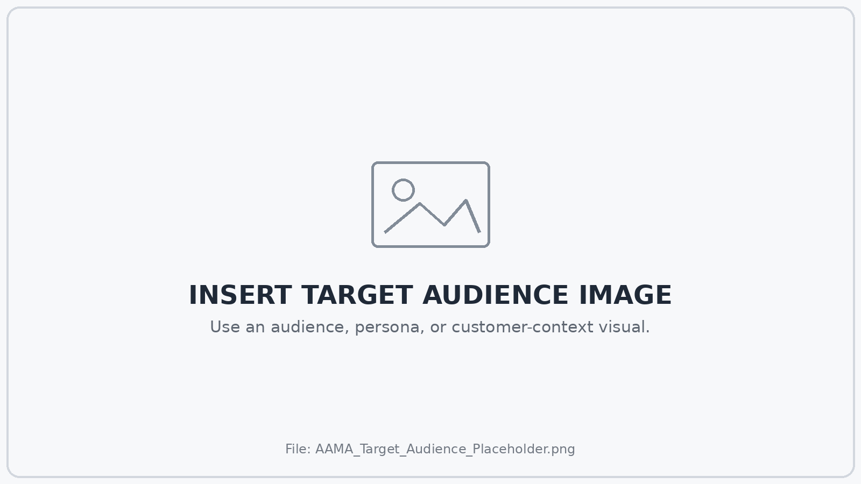
[Replace with audience, persona, stakeholder, or customer-context visual]
Planning Prompt | Response / Working Notes
Primary audience | [Who is the highest-priority audience for this plan?]
Relevant characteristics | [List demographic, firmographic, geographic, behavioral, attitudinal, or lifecycle traits that materially affect strategy.]
Need / job to be done | [What is the audience trying to accomplish, solve, avoid, or improve?]
Current behavior | [What do they do today? What alternatives do they use?]
Motivation | [What would make the desired action valuable to them?]
Barriers | [What prevents action, creates doubt, or slows the decision?]
Decision criteria | [What factors are most likely to determine choice?]
Evidence / sources | [List research, analytics, interviews, surveys, sales feedback, or other evidence supporting these insights.]

Audience Priority Matrix
Audience | Strategic Value | Need / Insight | Desired Action | Priority
[Audience 1] | [High / Medium / Low] | [Key need or insight] | [Desired action] | [1]
[Audience 2] | [High / Medium / Low] | [Key need or insight] | [Desired action] | [2]
[Audience 3] | [High / Medium / Low] | [Key need or insight] | [Desired action] | [3]

4. Competitive Landscape
Competitive analysis should focus on choices available to the audience, not only organizations that look similar on paper. Include direct competitors, substitutes, internal alternatives, and the option to do nothing when those choices affect the decision.
Competitor / Alternative | Audience Promise | Strengths | Weaknesses | Marketing Implication
[Competitor / Alternative 1] | [What do they promise?] | [Strengths] | [Weaknesses] | [Implication for us]
[Competitor / Alternative 2] | [What do they promise?] | [Strengths] | [Weaknesses] | [Implication for us]
[Competitor / Alternative 3] | [What do they promise?] | [Strengths] | [Weaknesses] | [Implication for us]

SWOT Summary
Strengths | Weaknesses | Opportunities | Threats
[Internal advantage] | [Internal limitation] | [External opportunity] | [External threat]
[Internal advantage] | [Internal limitation] | [External opportunity] | [External threat]
[Internal advantage] | [Internal limitation] | [External opportunity] | [External threat]

5. Business & Marketing Objectives
Objectives should describe measurable outcomes rather than lists of activity. Connect marketing objectives with the business result they are intended to support, and include a defined time period whenever possible.
Objective | Baseline | Target | Deadline | Business Connection
[Objective 1] | [Current level] | [Target level] | [Date] | [Business outcome supported]
[Objective 2] | [Current level] | [Target level] | [Date] | [Business outcome supported]
[Objective 3] | [Current level] | [Target level] | [Date] | [Business outcome supported]

Objective Quality Check
[ ] The objective describes an outcome rather than a tactic.
[ ] The baseline is known or a baseline measurement is planned.
[ ] The target is measurable.
[ ] The measurement period is defined.
[ ] The objective can be connected to a business priority.
[ ] The organization has enough influence over the outcome to manage against it.

6. Positioning & Messaging
Positioning defines the strategic place the offering should occupy in the audience's mind relative to alternatives. Messaging translates that position into language that can be adapted across channels and creative executions.
Planning Prompt | Response / Working Notes
Target audience | [For whom is the offering most relevant?]
Frame of reference | [What category, problem, need, or competitive set should the audience use to understand the offering?]
Primary benefit | [What is the most important value the audience receives?]
Differentiation | [Why should the audience choose this offering instead of alternatives?]
Reasons to believe | [What evidence, proof, experience, expertise, features, outcomes, or third-party validation supports the claim?]
Core message | [Write the central message in clear audience-facing language.]
Supporting messages | [List 2-4 supporting messages.]
Primary call to action | [What should the audience do next?]

Message Framework
Message Level | Purpose | Working Language
Core Message | Single central idea | [Insert core message]
Proof Point 1 | Evidence / substantiation | [Insert proof]
Proof Point 2 | Evidence / substantiation | [Insert proof]
Objection Response | Address a likely barrier | [Insert response]
Call to Action | Define next step | [Insert CTA]

7. Marketing Strategy
Strategy explains the choices that connect the situation and objectives with the eventual channel and campaign plan. It should clarify where the organization will focus, what it will prioritize, and what it will deliberately not attempt to do.
Planning Prompt | Response / Working Notes
Strategic approach | [Describe the overall approach in 1-3 paragraphs.]
Priority audience | [Identify the audience that receives primary investment and attention.]
Behavior / perception to change | [What must the audience think, feel, understand, or do differently?]
Value exchange | [Why is the desired action worthwhile for the audience?]
Primary strategic lever | [Examples: awareness, acquisition, conversion, retention, pricing, distribution, partnership, category education.]
Competitive choice | [How will the strategy distinguish the offering from alternatives?]
What we will not prioritize | [List major activities or audiences that are intentionally outside the plan.]

8. Channel & Media Plan
Assign each channel a specific role in the customer journey or communication strategy. Avoid selecting channels simply because they are common or currently popular.
Channel | Strategic Role | Audience | Primary KPI | Budget / Weight | Owner
[Channel 1] | [Role] | [Audience] | [KPI] | [Budget / %] | [Owner]
[Channel 2] | [Role] | [Audience] | [KPI] | [Budget / %] | [Owner]
[Channel 3] | [Role] | [Audience] | [KPI] | [Budget / %] | [Owner]
[Channel 4] | [Role] | [Audience] | [KPI] | [Budget / %] | [Owner]
[Channel 5] | [Role] | [Audience] | [KPI] | [Budget / %] | [Owner]

Channel Rationale
Planning Prompt | Response / Working Notes
Paid media | [Explain where paid advertising fits and why.]
Owned media | [Explain the role of website, email, CRM, social accounts, content, or other controlled channels.]
Earned media | [Explain the role of PR, word of mouth, reviews, community, advocacy, or organic coverage.]
Partnerships / distribution | [Explain the role of partners, retailers, affiliates, platforms, events, or other distribution relationships.]

9. Creative & Content Direction
Creative direction should translate the strategy into a coherent communication system while leaving room for channel-specific execution. Define the idea, message, proof, tone, and mandatory elements before individual assets are produced.
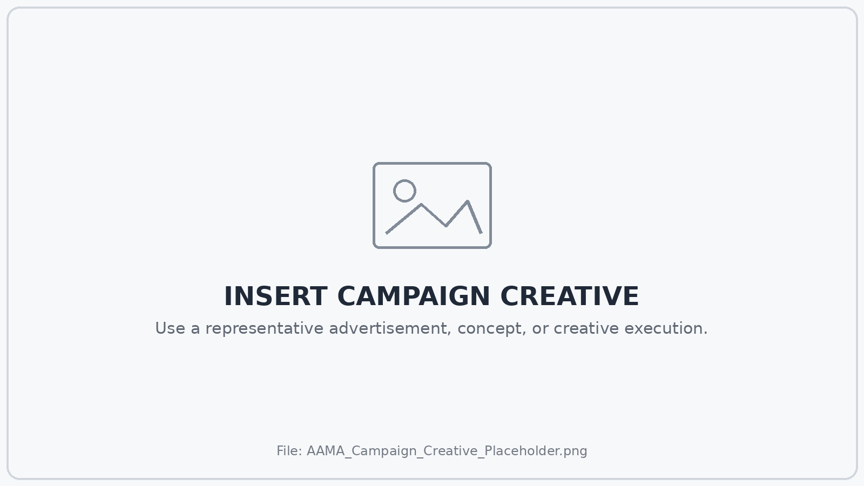
[Replace with representative campaign concept or creative execution]
Planning Prompt | Response / Working Notes
Creative objective | [What should the creative accomplish?]
Single-minded proposition | [What is the one idea the audience should take away?]
Tone / voice | [Describe how the communication should feel and sound.]
Mandatory elements | [List required claims, disclosures, brand elements, links, legal language, product information, or CTA.]
Content themes | [List recurring themes or editorial territories.]
Creative variations | [What messages, formats, audiences, or concepts should be tested?]

10. Marketing Calendar & Execution Plan
Translate strategy into a schedule with clear ownership, dependencies, and decision points. Use additional rows or a separate project-management system when execution requires more detail.
Timing | Initiative / Deliverable | Channel | Owner | Dependency | Status
[Date / Week] | [Initiative] | [Channel] | [Owner] | [Dependency] | [Planned]
[Date / Week] | [Initiative] | [Channel] | [Owner] | [Dependency] | [Planned]
[Date / Week] | [Initiative] | [Channel] | [Owner] | [Dependency] | [Planned]
[Date / Week] | [Initiative] | [Channel] | [Owner] | [Dependency] | [Planned]
[Date / Week] | [Initiative] | [Channel] | [Owner] | [Dependency] | [Planned]
[Date / Week] | [Initiative] | [Channel] | [Owner] | [Dependency] | [Planned]

11. Marketing Budget
Budget should reflect the strategy, not simply repeat last year's allocation. Distinguish working media from production, staffing, technology, agency, research, promotions, and other costs when those distinctions affect decisions.
Budget Category | Planned | Committed | Actual | Variance | Notes
Paid media | [$0] | [$0] | [$0] | [$0] | [Notes]
Creative / production | [$0] | [$0] | [$0] | [$0] | [Notes]
Agency / contractors | [$0] | [$0] | [$0] | [$0] | [Notes]
Technology / software | [$0] | [$0] | [$0] | [$0] | [Notes]
Research / testing | [$0] | [$0] | [$0] | [$0] | [Notes]
Events / partnerships | [$0] | [$0] | [$0] | [$0] | [Notes]
Other | [$0] | [$0] | [$0] | [$0] | [Notes]
TOTAL | [$0] | [$0] | [$0] | [$0]

Planning Prompt | Response / Working Notes
Budget assumptions | [Document major assumptions behind the budget.]
Contingency | [State whether reserve or contingency funds are available and how they may be used.]
Reallocation rules | [Define when and how budget may move between channels or initiatives.]

12. Measurement & KPI Framework
Measurement should connect activity with the objectives established earlier in the plan. Define formulas, data sources, reporting cadence, and decision thresholds before launch when possible.
Objective / Question | KPI | Baseline | Target | Data Source | Cadence | Owner
[Objective 1] | [KPI] | [Baseline] | [Target] | [Source] | [Weekly / Monthly] | [Owner]
[Objective 2] | [KPI] | [Baseline] | [Target] | [Source] | [Weekly / Monthly] | [Owner]
[Objective 3] | [KPI] | [Baseline] | [Target] | [Source] | [Weekly / Monthly] | [Owner]

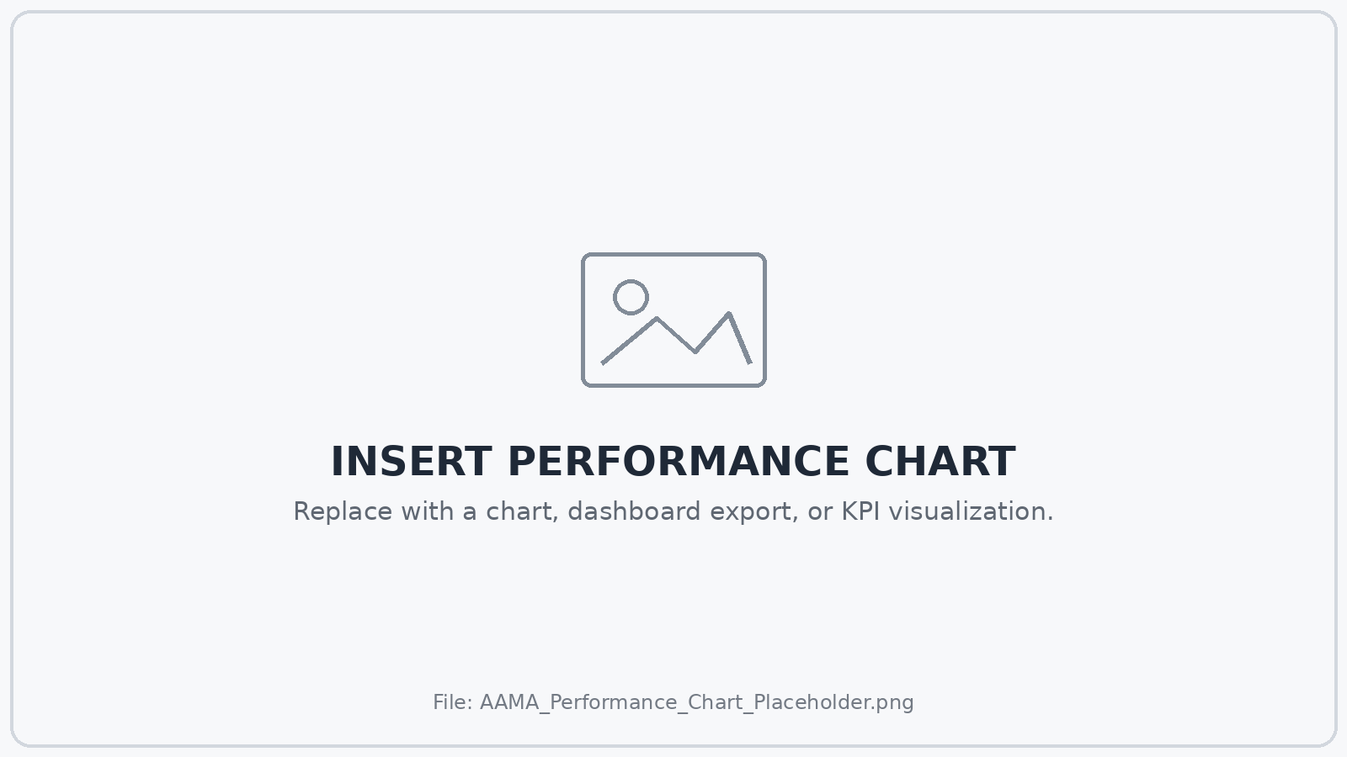
[Replace with KPI dashboard, chart, or performance visualization]

Measurement Notes
Planning Prompt | Response / Working Notes
Attribution approach | [Document how marketing activity will receive credit for outcomes.]
Tracking requirements | [List analytics, CRM, UTM, platform, offline, or other tracking requirements.]
Data limitations | [Identify known measurement gaps or uncertainties.]
Decision thresholds | [Define the performance levels that would trigger optimization, budget changes, or strategic review.]

13. Testing & Optimization Plan
Testing should answer decisions that matter. Prioritize tests that can change creative, audience, offer, channel, landing-page, budget, or customer-experience choices rather than testing simply because experimentation is available.
Hypothesis | Variable | Primary Metric | Decision Rule | Timing | Status
[If we change X, we expect Y because Z.] | [Variable] | [Metric] | [What result changes the decision?] | [Dates] | [Planned]
[Hypothesis] | [Variable] | [Metric] | [Decision rule] | [Dates] | [Planned]
[Hypothesis] | [Variable] | [Metric] | [Decision rule] | [Dates] | [Planned]

Planning Prompt | Response / Working Notes
Optimization cadence | [How often will performance be reviewed and who can authorize changes?]
Protected learning period | [If relevant, define how long campaigns should run before routine optimization.]
Scale criteria | [What evidence would justify increased investment?]
Stop / revise criteria | [What evidence would justify pausing, replacing, or materially changing an initiative?]

14. Risks, Dependencies & Governance
Identify conditions that could prevent the plan from working as intended. Include operational, financial, regulatory, reputational, creative, measurement, and market risks when they are material.
Risk / Dependency | Likelihood | Impact | Mitigation / Response | Owner
[Risk 1] | [Low / Med / High] | [Low / Med / High] | [Mitigation] | [Owner]
[Risk 2] | [Low / Med / High] | [Low / Med / High] | [Mitigation] | [Owner]
[Risk 3] | [Low / Med / High] | [Low / Med / High] | [Mitigation] | [Owner]

Approvals & Decision Rights
Decision | Recommends | Approves | Consulted / Informed
Strategy | [Name / Role] | [Name / Role] | [Names / Roles]
Budget | [Name / Role] | [Name / Role] | [Names / Roles]
Creative | [Name / Role] | [Name / Role] | [Names / Roles]
Media changes | [Name / Role] | [Name / Role] | [Names / Roles]
Claims / legal review | [Name / Role] | [Name / Role] | [Names / Roles]

15. Final Plan Review
Use this review before presenting, approving, or distributing the marketing plan. A complete plan should make the strategic logic visible from evidence through execution and measurement.
[ ] The business context and marketing problem are clear.
[ ] Objectives are measurable and connected to business priorities.
[ ] Audience choices are supported by evidence.
[ ] Positioning and messaging reflect a real customer need and meaningful differentiation.
[ ] Strategy identifies priorities and deliberate tradeoffs.
[ ] Every major channel has a defined role.
[ ] Creative direction follows from the strategy.
[ ] The calendar includes clear ownership and dependencies.
[ ] Budget assumptions are documented.
[ ] KPIs, data sources, and reporting cadence are defined.
[ ] Testing and optimization rules are established.
[ ] Material risks and approval requirements are documented.
[ ] All bracketed instructions and placeholder content have been replaced or removed.
[ ] All claims, disclosures, data, citations, and legal requirements have been reviewed where applicable.

Approval
Role | Name | Approval / Signature | Date
Marketing Lead | [Name] | [Approval] | [Date]
Business / Executive Lead | [Name] | [Approval] | [Date]
Finance / Budget Owner | [Name] | [Approval] | [Date]
Other | [Name] | [Approval] | [Date]

Template originally provided by the American Advertising and Marketing Association.

